**Spring 2024: CS5720**

**Neural Networks and Deep Learning - ICP-3**

**Yasaswini Majety(700747747)**

**Github link:** <https://github.com/yasaswini8777/Neural-Network-ICP3>

1. Create a class Employee and then do the following

* Create a data member to count the number of Employees
* Create a constructor to initialize name, family, salary, department
* Create a function to average salary
* Create a Fulltime Employee class and it should inherit the properties of Employee class
* Create the instances of Fulltime Employee class and Employee class and call their member functions.

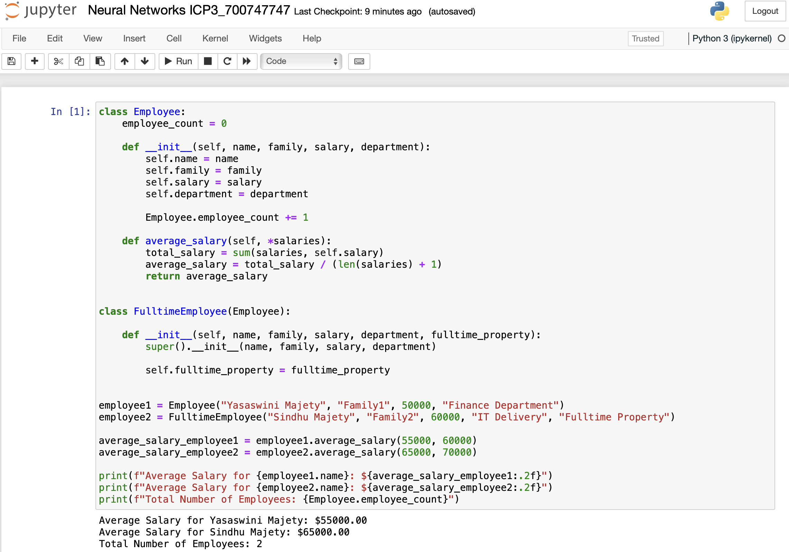

2. Using NumPy create random vector of size 20 having only float in the range 1-20. Then reshape the array to 4 by 5 Then replace the max in each row by 0 (axis=1) (you can NOT implement it via for loop)

